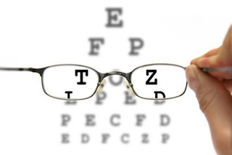
Good vision helps you perform well—in sports, hanging out with your friends, or in school. It may be tough to fit everything in your schedule, but your eyes will feel the difference when you get the sleep you need. Getting at least 8 hours of sleep at night maintains good eye health.

The best protection for your vision is through regular eye exams. Make sure you get your eyes regularly checked every two years by an eye doctor. Of course, if you notice a change in your vision —or your eye is injured in any way— you should contact your eye care professional right away.

Did you know that eating junk food is not good for your eyes? Eating a healthy diet rich in antioxidants and Vitamin C (like fruits, nuts, and vegetables) is important for healthy eyes.

You’re probably doing most class assignments on a computer, looking at the screen for hours at a stretch. Be sure to take 20! Every 20 minutes, look 20 feet away for 20 seconds. Your eyes will be healthier for it!

Once your homework is done, you might be texting friends, chatting on Facebook, or watching YouTube videos. Screen time can be hard on your eyes. For better eye health, limit your screen time to less than two hours a day.

Exercise improves blood and oxygen flow to your eyes. For good eye health, be sure to exercise at least 60 minutes a day and wear protective eyewear when doing activities that put your eyes at risk of injury.

Sunglasses are a great fashion accessory, but their most important job is to protect your eyes from the sun’s ultraviolet (UV) rays. When purchasing sunglasses, look for lenses that block out 99 to 100% of both UVA and UVB radiation. Protecting your eyes from the sun keeps your vision sharp and eyes healthy.

